The code is a Java program that publishes and subscribes to MQTT messages using the Eclipse Paho MQTT client library. The program simulates pollution data publishing from two different cities, Aarhus1 and Aarhus2. The pollution data is read from CSV files and published to the MQTT broker at a regular interval of 10 seconds.The program defines two topics for the publishers and subscriber, respectively, as `mytopic/Arhus1` and `mytopic/Aarhus2`. The MQTT broker host and port are also defined as `mqtt.eclipseprojects.io` and `1883`, respectively.The program defines three functions to read data from the CSV file, publish data to the MQTT broker, and handle the callback function for the subscriber. The CSV data reading function uses the OpenCSV library to read the CSV files and return the data as a list of string arrays. The publish_data function takes the MQTT client, topic, and data as input and publishes the data to the MQTT broker using the client's `publish()` method. The subscriber's callback function implements the `MqttCallback` interface and is used to handle incoming messages. In this program, the `messageArrived()` method is implemented to print the received message to the console.In the `main()` method, the program first initializes the MQTT clients for both publishers and subscribers, connects them to the MQTT broker, and subscribes to the defined topics. The program then reads data from the CSV files for Aarhus1 and Aarhus2 publishers and publishes data to their respective topics every 10 seconds in an infinite loop. The `Thread.sleep()` method is used to pause the program execution for 10 seconds between publishing cycles.

Finally, the program stops the subscriber client after exiting the publishing loop.

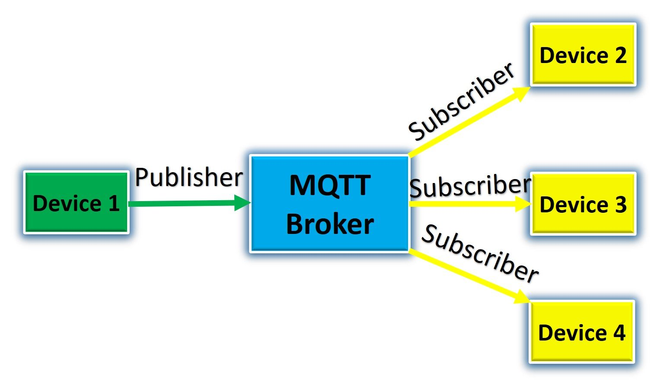

**The below image contains information about the code snippet and its output below:**

